Drawing a Hand

Begin with simple shapes and lines

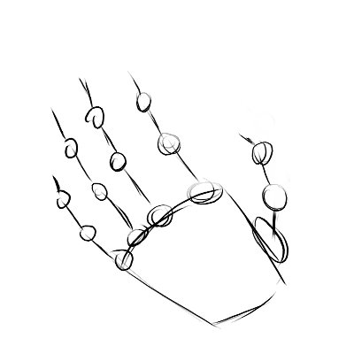

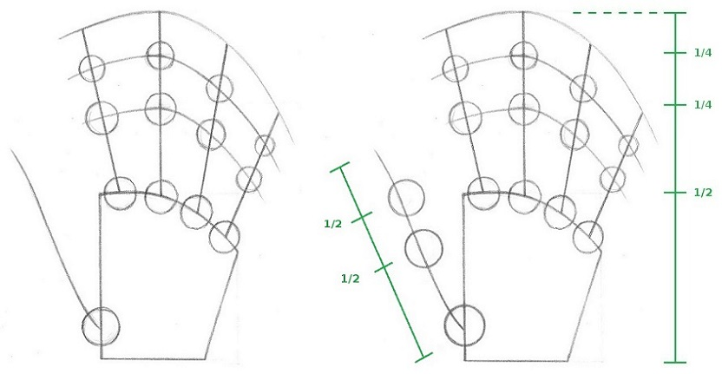

Remember to think about the joints in your fingers, the length, and where each finger is located

Begin to add shapes around the lines to build up the width of your fingers

